SQL DAY 6 LAB Assignment Procedures

01_Aaditya Sudhir Joshi

1. Create a procedure to display all records from department table

Answer:- Command=>

use demo;

drop procedure if exists GetDepartment;

DELIMITER //

create procedure GetDepartment()

BEGIN

select * from Department;

END//

DELIMITER ;

Call GetDepartment();

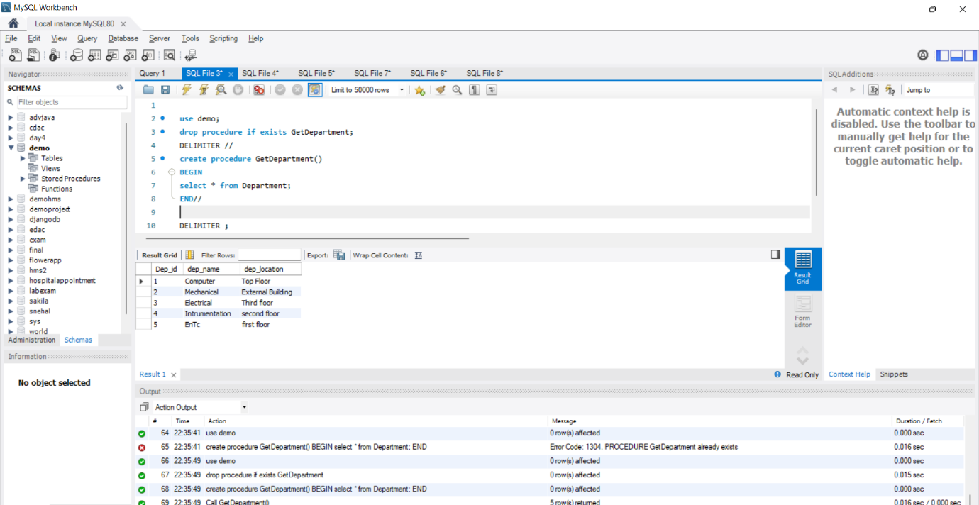

2. Create a procedure to return and display employe id, employee name, department name and department location by passing employee id to the procedure

Answer :-

Command=>

use demo;

drop procedure if exists GetDisplayed;

delimiter //

create procedure GetDisplayed(

in id int,

out employee_name varchar(20),

out department_name varchar(20),

out department_location varchar(20))

begin

select employee.emp_name,department.dep_name,department.dep_location into employee_name,department_name,department_location

from department inner join employee

on department.Dep_id = employee.dept_id and employee.Emp_id = id;

end //

delimiter ;

call GetDisplayed(2,@employee_name,@department_name, @department_location);

select @employee_name,@department_name ,@department_location ;

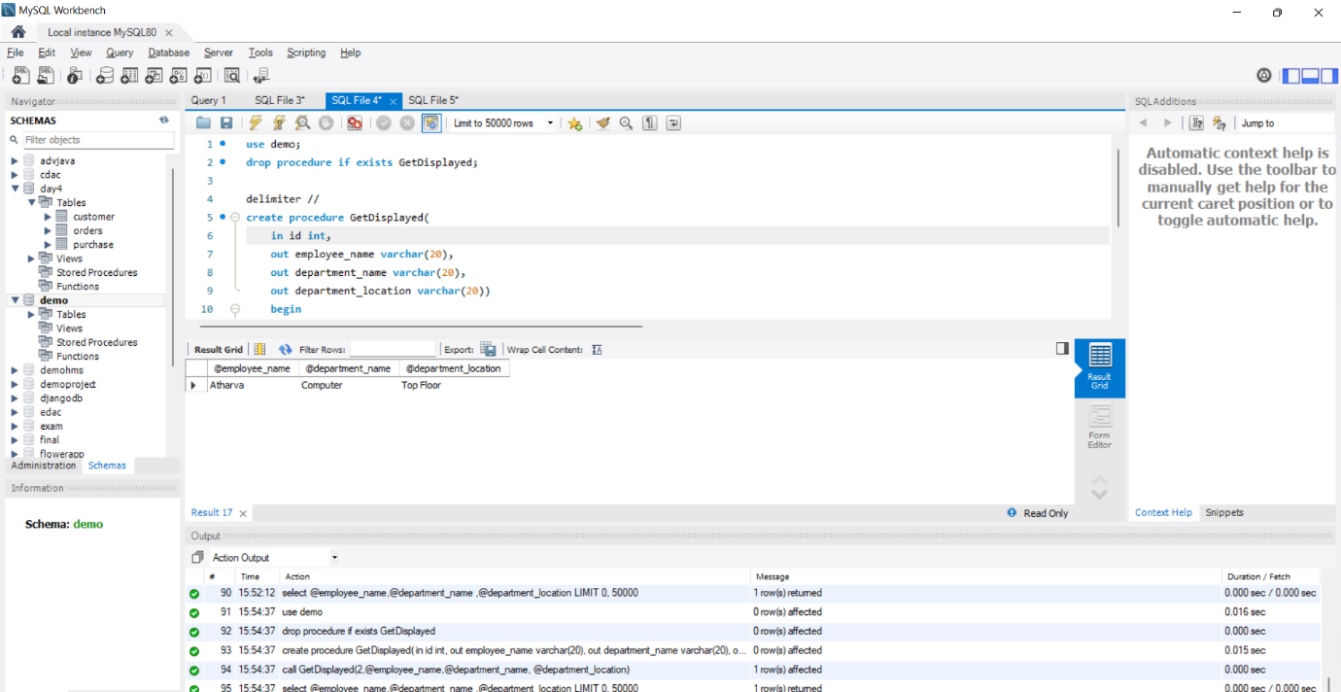

3. Create a copy of the table employee

4. Create a procedure to move some records one by one from employee table to

employee copy table for some selected departments using while/repeat /loop

Ie write the same program with different looping structures.

Answer :-

Command Code :-

use demo;

DELIMITER //

drop procedure if exists copye;

create procedure copye()

BEGIN

declare c int;

declare i int;

set i=0;

set c=0;

select count(*) from employee into c;

while (i<c) do

insert into emp1(Emp_id,emp_name,job_name,salary,commission,dept_id) select * from employee limit i,1;

set i=i+1;

END WHILE;

END //

DELIMITER ;

call copye();

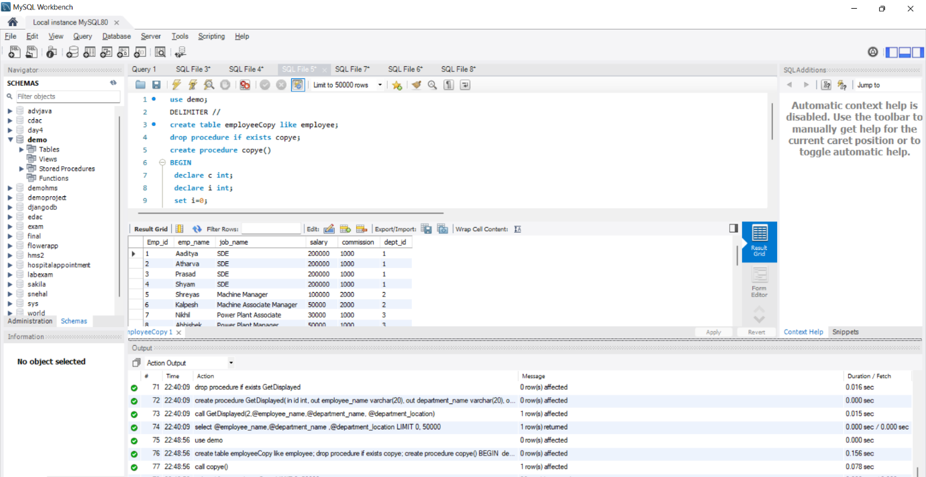

use demo;

delimiter //

drop procedure if exists useofrepeat;

create procedure useofrepeat(

in id int,

out Emp_id varchar(20),

out emp_name varchar(20),

out job_name varchar(20),

out salary varchar(20),

out commission varchar(20)

)

begin

declare c int;

declare i int;

set i=0;

set c=0;

select count(*) from employee into c;

repeat

insert into repeatedemp( Emp_id, emp_name, job_name, salary ,commission )

select employee.Emp_id, employee.emp_name, employee.job_name, employee.salary ,employee.commission

into id, Emp_id, emp_name, job_name, salary, commission

from employee inner join department

on department.dep_id = employee.dept_id and department.dep_id=id limit i, 1;

set i=i+1;

until i>c

end repeat;

end //

call useofrepeat(1, @Emp_id, @emp_name, @job_name, @salary, @commission);

select * from repeatedemp;

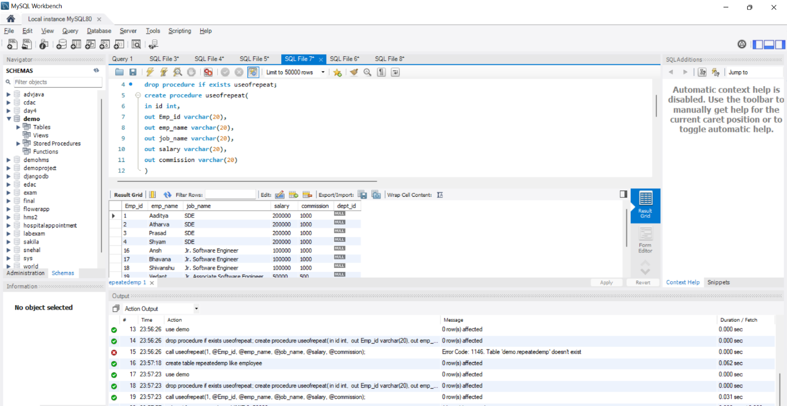

use demo;

delimiter //

drop procedure if exists usingloop;

create procedure usingloop(

in id int,

out Emp_id varchar(20),

out emp_name varchar(20),

out job_name varchar(20),

out salary varchar(20),

out commission varchar(20)

)

begin

declare c int;

declare i int;

set i=0;

set c=0;

select count(*) from employee into c;

label: loop

if(i>c) then leave label;

else

insert into usedloop( Emp_id, emp_name, job_name, salary ,commission )

select employee.Emp_id, employee.emp_name, employee.job_name, employee.salary ,employee.commission

into id, Emp_id, emp_name, job_name, salary, commission

from employee inner join department

on department.dep_id = employee.dept_id and department.dep_id=id limit i, 1;

set i=i+1;

end if;

end loop;

end //

call usingloop(1, @Emp_id, @emp_name, @job_name, @salary , @commission);

select * from usedloop;

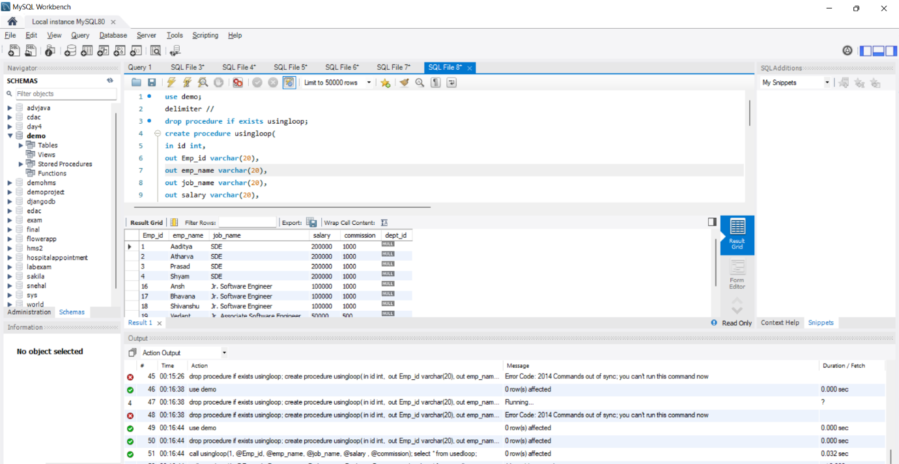

5. Create a procedure to delete the departments from department table by passing

department id as the IN parameter which doesn’t have corresponding records in

employee table.

Use IF THEN END IF structure to check in employee table and ensure there is no child

records . Department record to be deleted only if the employee table check is true.

Answer:-

Command=>

use demo;

DELIMITER //

drop procedure if exists deletedepartment;

create procedure deletedepartment(in id int)

BEGIN

IF exists ( select dept_id from employee where dept_id = id ) then

select 'child already exists, We cant delete this department';

select count(dept_id) from employee where dept_id = id;

else

delete from department where dep_id = id;

end if;

END //

DELIMITER ;

call deletedepartment(1);

